Types of Constructive and Resulting trusts

Constructive Trusts
These are imposed by the court to prevent unfairness or wrongdoing.
- Institutional Constructive Trusts:
  - Arise automatically when there’s a breach of duty, fraud, or wrongdoing.
  - Example: A trustee misuses trust property—an institutional constructive trust arises immediately.
- Remedial Constructive Trusts:
  - Imposed at the court's discretion as a remedy to fix unjust enrichment or unfair situations.
  - Example: If someone unfairly benefits at your expense, the court can impose this trust.

Resulting Trusts
These return property to the original owner (or transferor) when it’s clear they didn’t intend to give it away.
- Automatic Resulting Trusts:
- Happen automatically When a trust fails (e.g., due to uncertainty or illegality), equity automatically returns the beneficial interest to the transferor.
- Example: A trust is created for “charity,” but no clear purpose exists—the property goes back to the settlor.
- Presumed Resulting Trusts:
  - Arise when someone transfers property with no explanation or payment (no consideration). The law presumes they didn’t intend to gift it.
  - Example: A gives £10,000 to B without a reason—B holds it on trust for A unless they prove it was a gift.

Remedial constructive trusts and resulting trusts

1. Presumed- intention Resulting Trusts
- Purpose: Resulting trusts arise to give effect to the presumed intention of the parties or to return property to the original owner when a trust fails or does not exhaust all the property.
- Key Characteristic: They are based on intention—whether actual or presumed—but not fraud or wrongdoing.
- Types:
  - Automatic resulting trust: Happens when an express trust fails (e.g., incomplete transfer, beneficiary cannot be determined).
  - Presumed resulting trust: Happens when property is transferred without payment or consideration, and the recipient is presumed to hold it on trust for the transferor (e.g., voluntary transfer of property to another).
- Intention: A resulting trust arises when the law presumes the transferor did not intend to give away the property outright, even if intention isn’t explicitly stated.
Example:
A transfers £10,000 to B without explanation or agreement. In the absence of evidence showing A intended a gift, the law presumes B holds the money on resulting trust for A.

2. Remedial Constructive Trusts
- Purpose: A remedial constructive trust is a remedy imposed by the courts to prevent unjust enrichment or address wrongdoing.
- Key Characteristic: They are not based on the parties’ intention, but instead arise due to the court’s intervention to achieve equitable justice.
- Intention: Unlike resulting trusts, remedial constructive trusts do not depend on any intention (actual or presumed). Instead, they are imposed as a consequence of wrongdoing (e.g., fraud, breach of fiduciary duty) or where it would be unconscionable for the recipient to retain the benefit.
- Discretionary: The court has discretion in determining whether a constructive trust should arise and its extent.
Example:
A fiduciary misappropriates funds or profits unfairly in a breach of duty. The court imposes a remedial constructive trust on those profits, requiring the wrongdoer to hold them for the benefit of the rightful owner.

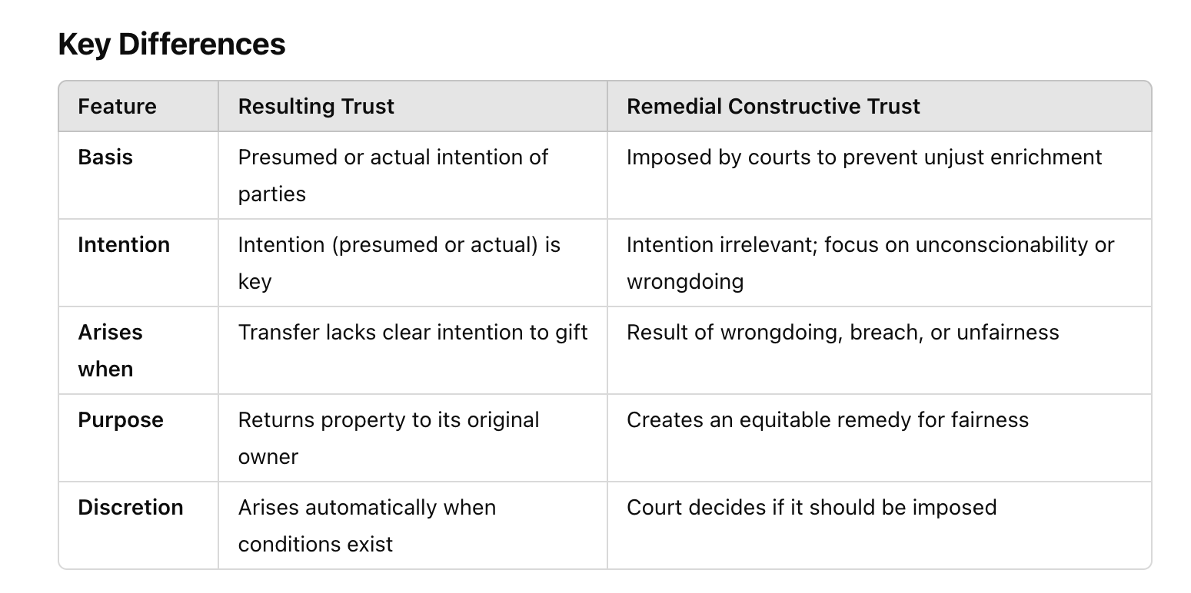

Types of Resulting Trust

1. Automatic Resulting Trust
Intention: No need to find intention explicitly.
- An automatic resulting trust arises by operation of law when an express trust fails (e.g., the trust property cannot be distributed, or the beneficial interest is not fully disposed of).
- The law presumes the property should "result" back to the settlor or their estate.
- It does not require any active consideration of the settlor's intention because the failure of the express trust triggers the resulting trust automatically.
Example:
A sets up a trust for "charitable purposes," but the chosen purpose is too vague or does not exist. The property automatically results back to A (the settlor).

2. Presumed Resulting Trust
Court's Role:
- The court applies the presumption as a starting point.
- If no evidence proves otherwise, the court will find that a resulting trust arises based on the presumed intention.
Example:
A gives £50,000 to B, but there’s no explanation for the transfer.
The law presumes B holds the money on a resulting trust for A unless B proves that A intended it as a gift.

Presumed intention vs Actual intention

Presumed Intention
Nature: A legal assumption made by the court based on the circumstances of the transfer.
Why?: The presumption arises when a transfer occurs without consideration (e.g., no payment or compensation) and no explanation is provided for the transfer.
Role: The law presumes that the transferor did not intend to gift the property and intended to retain a beneficial interest in it.
Burden of Proof: The person receiving the property (the transferee) must rebut the presumption by proving there was an actual intention to make a gift.
Example:
A transfers £10,000 to B with no explanation or written agreement.
The court presumes A did not intend to gift the money, so B holds it on a presumed resulting trust for A.
B can rebut this presumption by proving A’s actual intention was to gift the money.

Actual Intention
Nature: The real, factual intention of the transferor at the time of the transfer.
How It’s Shown: Evidence such as written agreements, verbal statements, conduct, or other circumstances that demonstrate the transferor's true intention.
Role: If actual intention can be proven, it overrides the presumed intention.
Outcome:
  - If actual intention to gift is proven → No resulting trust arises.
  - If no evidence of actual intention → The presumption stands (resulting trust applies).
Example:
- A transfers £10,000 to B and states in writing, "This is a gift to help you."
- This evidence proves A’s actual intention to make a gift, so the court will not impose a resulting trust.

